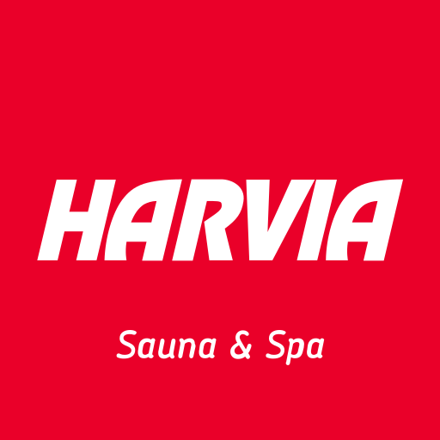
How to Connect to Harvia Devices and Cloud?
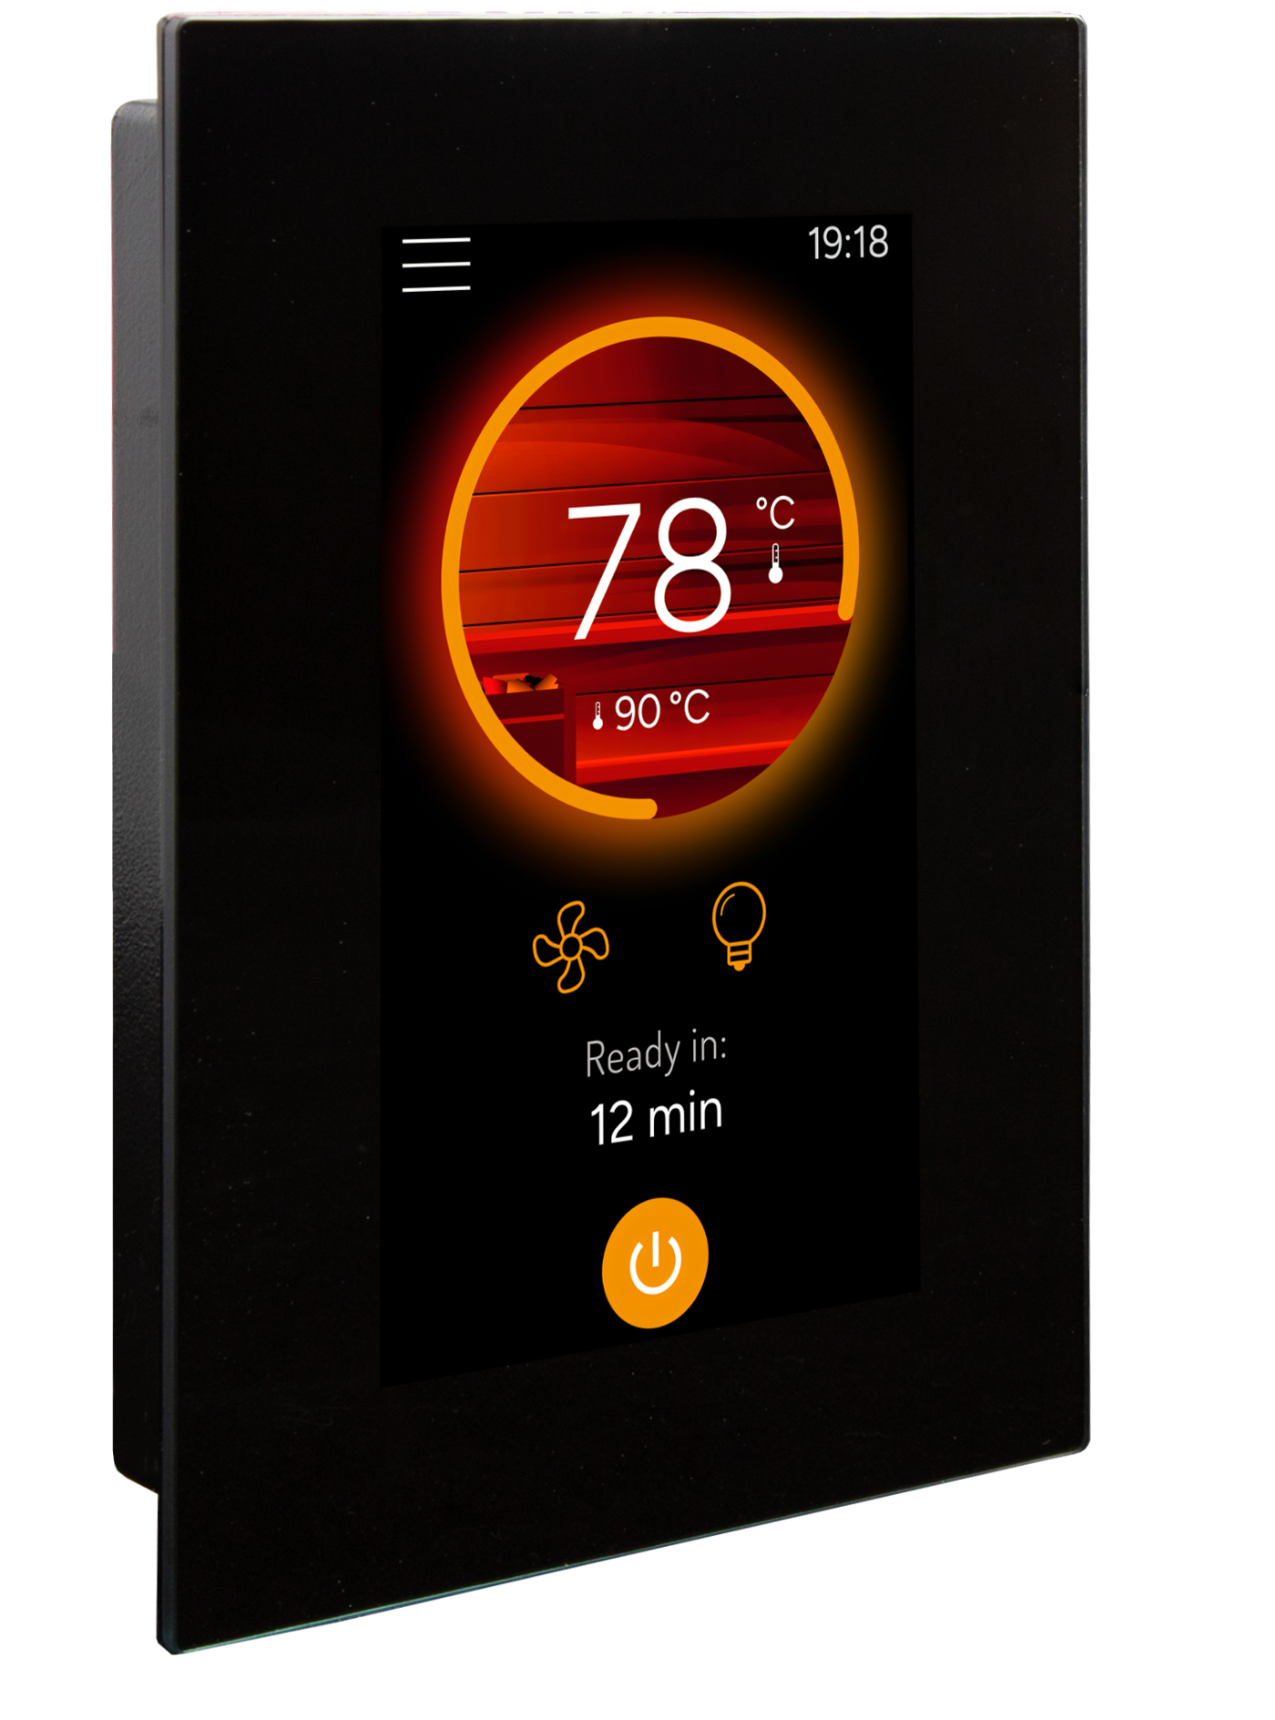
Harvia launched a new connected sauna control unit, Harvia Fenix, in 2025, featuring
a 4.3” touch panel and an intuitive, modern user interface.
🔗 Learn more about Harvia Fenix
Fenix control panel connects to Harvia Cloud via WiFi.
Each sauna session is automatically stored in the Harvia Cloud. As heating data accumulates, each device “learns”
the sauna’s heating curve and displays the estimated remaining heating time.
Notifications (e.g. Sauna ready) are sent to the user’s
mobile devices.

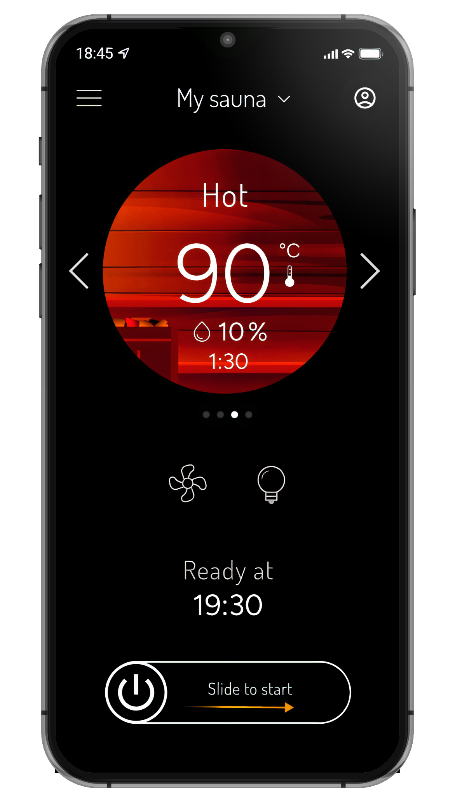
Remote Control via MyHarvia App
Remote control of the sauna is available through the mobile app. Harvia launched the new MyHarvia 2 app in 2025.
🔗 Learn more about MyHarvia 2
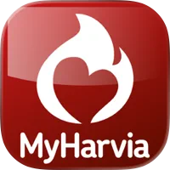
The app is available on both the Apple App
Store and Google Play Store, and includes
a demo mode so you can explore its features without connecting to a sauna.
🔗 App Store
🔗 Google Play
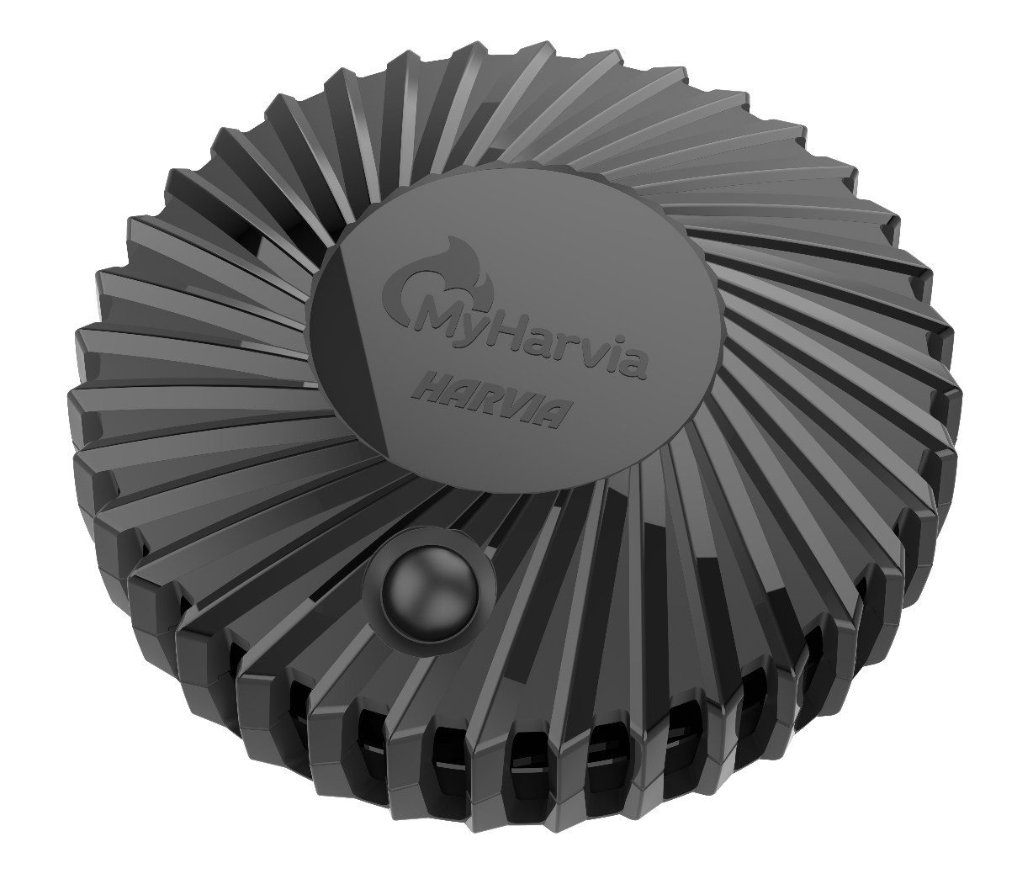
MyHarvia Smart Sauna Sensor
Harvia is about to launch a new sauna IoT device in December 2025, the MyHarvia Smart Sauna Sensor.
The first WiFi connected version will be introduced to
Junction Hackathon teams as pre-sales samples.
A cellular + WiFi version will follow later.
Each team participating in the Harvia challenge will receive
a device, which the team can keep also after the event.
The MyHarvia Smart Sauna Sensor can be used in any sauna, regardless of the sauna manufacturer. MyHarvia Smart Sauna Sensor is also a great way to connect a wood
-burning sauna to the MyHarvia app.MyHarvia Smart Sauna sensor turns any sauna into a smart sauna.
Once connected, the app displays the remaining heating time and sends notifications to your mobile phone and to compatible connected devices such as Apple Watch.
Notifications include:
- The sauna is ready
- The sauna is heating up slower or faster than usual
- Add firewood (when using a wood-burning heater)
- Ready sauna has remained unused for over 30 minutes
📘 MyHarvia Smart Sauna Sensor Manual
harvia.io & Harvia API
All data stored in Harvia Cloud can also be accessed via the harvia.io web portal and
the Harvia API - 🔗 harvia.io/api.
The Junction venue features 4 saunas, each equipped with MyHarvia Smart Sauna Sensors.
Use the Junction Hackathon test account to login to MyHarvia app, harvia.io and
access the devices through the API
usr: harviahackathon2025@gmail.com
pwd: junction25!
Harvia booth at the venue also features 2 miniature demo saunas, both equipped with
a Fenix control panel and a MyHarvia Smart Sauna Sensor.
Feel free to explore all the devices through the test account.
⚠️ Please avoid sending too many repeated commands to the Fenix devices, as all teams share the same demo units simultaneously.
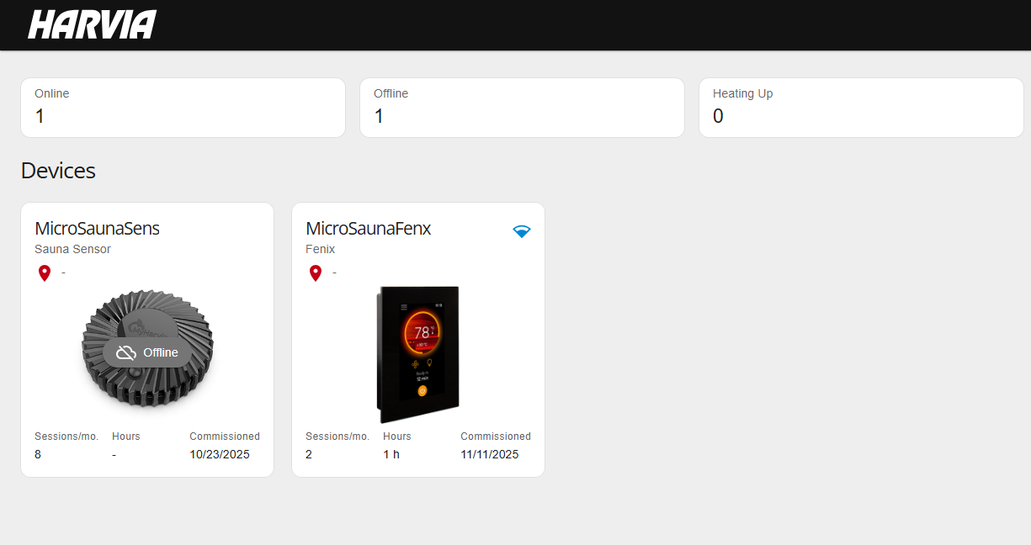
Log in to harvia.io using Junction Hackathon test account to see the devices at the venue

Extended Race - Harvia 30-day Challenge
In addition to the initial Harvia challenge at the Junction event, teams can join the first-ever Junction extended 30-day race.
Teams already participating in the Harvia challenge at the main event may continue developing their first-phase solution or create an entirely new one – even multiple solutions are allowed.
Teams not participating in the Harvia challenge at the main event may apply for the 30-day rave and a MyHarvia Smart Sauna Sensor for their team by sending a short motivation letter via WA to +358 50 537 2722 or via email to perttu.ronkko@harvia.com.
Teams must submit their solutions by 16.12.2025 18:00 EET though the Junction Platform. Results for the Race will be announced on Mon 22.12.2025 at hackjunction.com. The prize pool for the extended race is €1500.
Top-performing extended race teams will be invited to Harvia’s XQ event at the world’s largest sauna factory, where the awards ceremony will peak in the legendary Backyard Paradise saunas.

Join Harvia to reimagine the digital sauna experience
🔗 Senior Software Developer / Software Architect (AI-Native development)
🔗 Software Developer (AI-Native development)

